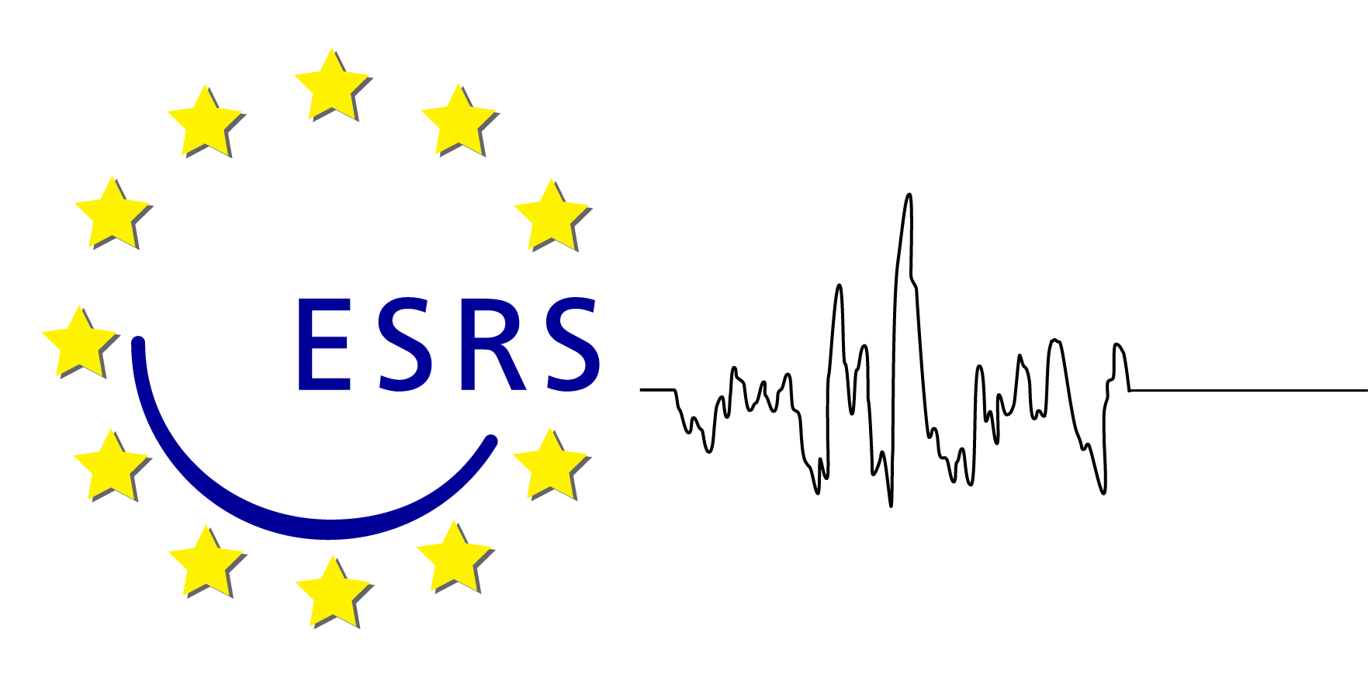

Sleep Medicine Textbook

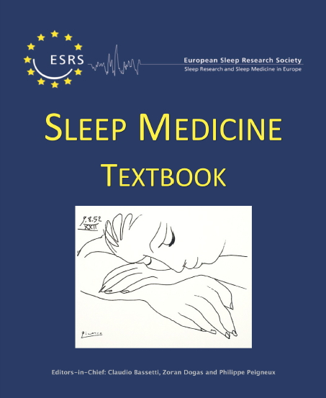
Editors: Claudio Bassetti, Zoran Dogas, Philippe Peigneux
Publisher: European Sleep Research Society (ESRS)
Regensburg, 2014
ISBN: 9781119038931
The Sleep Medicine Textbook provides comprehensive, all-in-one educational material (550 pages) structured around the Catalogue of knowledge and skills for sleep medicine (Penzel et al. 2014, Journal of Sleep Research). Written by experts in the field and published by the ESRS, it provides a European approach to sleep medicine education, and represents the knowledge-base for the ESRS-endorsed sleep medicine examinations.
Endorsed by ERS
 | ESRS Members* | ESRS Early Career Research Network (ECRN)** | Non-Members
Price per copy | € 140 | € 120 | € 155
* As a courtesy of ESRS, members of the Associate National Sleep Societies (ANSS), the European Biological Rhythms Society (EBRS) and the European Respiratory Society (ERS) benefit from the reduced price.
** ECRN members benefit from the student price (see conditions).

BOOK ORDER

Fax/ email this form to Maria Wiechmann (ESRS Office) +49 941 29080975 / maria.wiechmann@esrs.eu
I hereby order ________ copy/ copies of the
Sleep Medicine Textbook (Editors: Claudio Bassetti, Zoran Dogas, Philippe Peigneux) at copy price
☐ € 140 (ESRS, ANSS, EBRS and ERS members) ☐ € 120 (ECRN members) ☐ € 155 (non-members)
I am a member of:
☐ ESRS ☐ ANSS* ☐ EBRS* ☐ ERS*
* Please include a membership certificate.
☐ ESRS-ECRN **
** Reduced price for ESRS members during studentship and 5 years after having received a degree as PhD or MD. Please include appropriate certificates.
Payment method
☐ Master Card ☐ Am. Exp. ☐ Visa ☐ Diners ☐ Bank Transfer

Credit cards: will be debited at the time of expedition only
PayPal option: a link will be sent to your email address to go the PayPal webpage and proceed to payment
Delivery costs (to be added to the net price):
☐ € 8,90 (inside Europe*) ☐ € 15,90 (outside Europe)
☐ € 13,99 (with shipment tracking inside Europe*) ☐ € 28,99 (with shipment tracking outside Europe)
* Austria, Belgium, Bulgaria, Croatia, Cyprus, Czech Republic, Denmark, Estonia, Finland, France, Greece, Hungary, Ireland, Italy, Latvia, Lithuania, Luxembourg, Malta, Monaco, Poland, Portugal, Rumania, Slovakia, Slovenia, Spain, Sweden, The Netherlands, UK
Card No.

Date of expiration

Date: Signature:

Name in block letters:

Email address:

The book should be sent to the following address:

