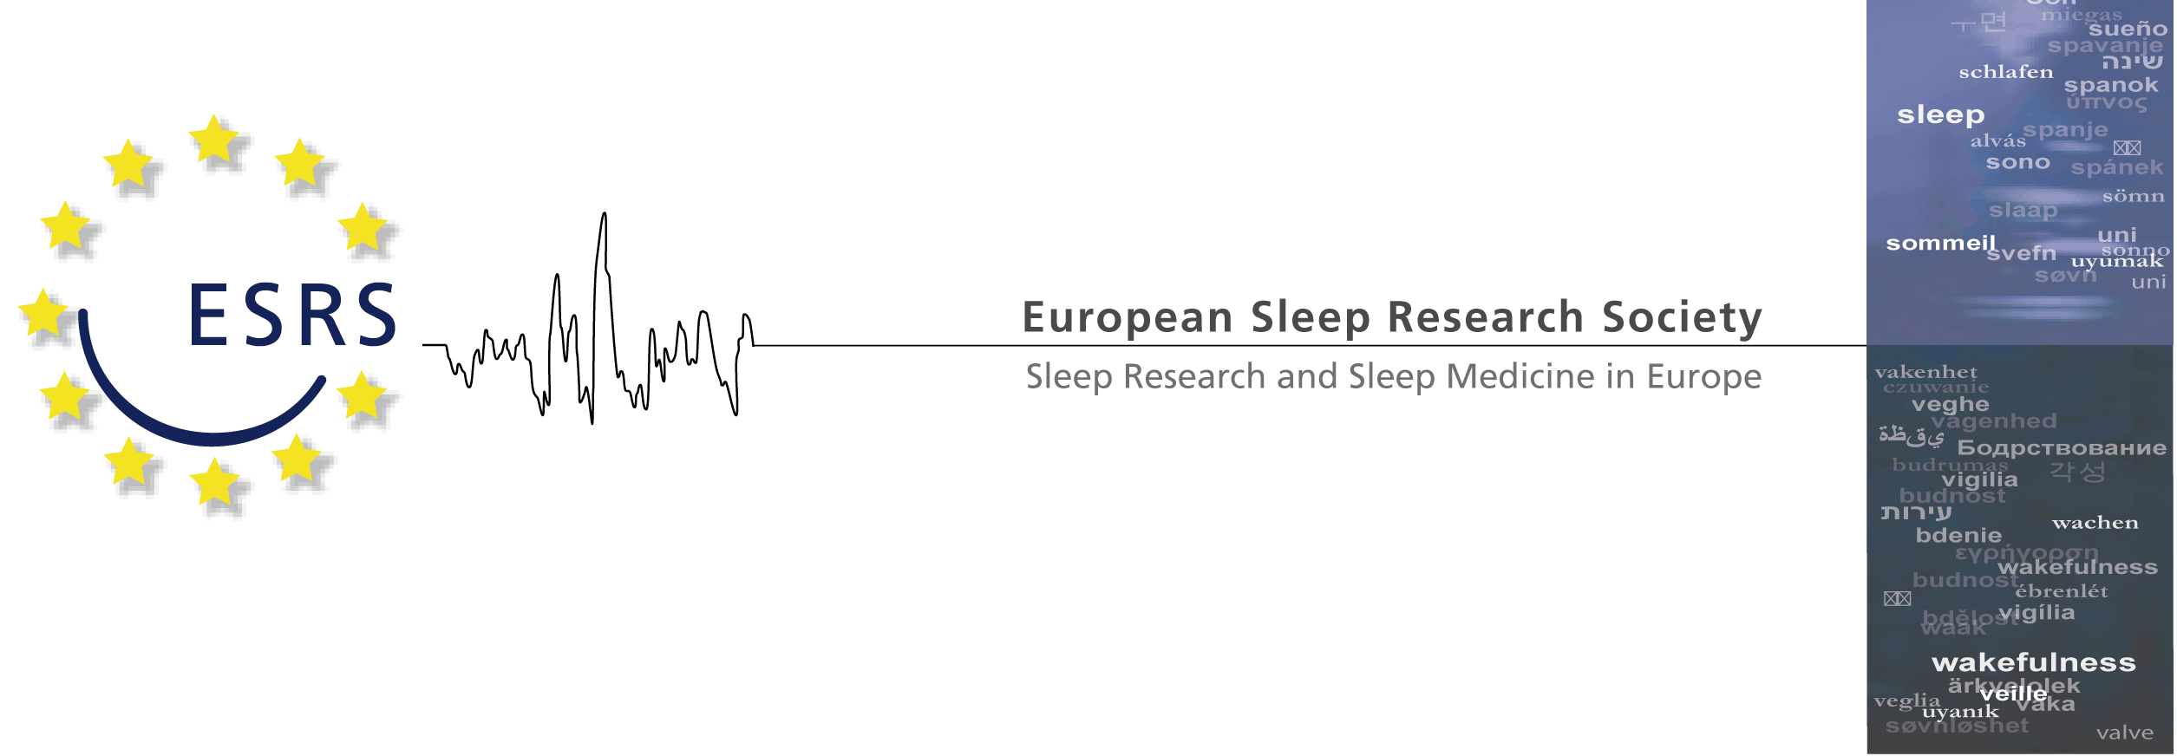

European Sleep Research Society, Günzstr. 4, 93059 REGENSBURG, GERMANY

Application Form:
ESRS patronage and financial support for Sleep Training Courses
Please submit the completed form to the President of the ESRS with a copy to the Assistant Secretary of the ESRS via the ESRS office (vroni.aumeier@esrs.eu).
1. Name of organizing National Society/Medical or Scientific Organization

2. Responsible/contact person (please send a short CV/Biosketch)
Name:
Tel., Fax:
E-Mail:

3. Name of conference (please send a preliminary program)

4. Suggested/preferred date(s)

5. Audience (which specialists will be invited, number of people expected)

6. Suggested topics and speakers (4-6 topics)
1.
2.
3.
4.
5.
6.
7. Please indicate the level of support requested from ESRS:

a. advertise on ESRS website and Newsletter
b. ESRS endorsement
c. an ESRS sleep training course*

8. Please specify the amount requested from ESRS (attach a detailed budget)

*For an ESRS sleep training course, the following criteria apply
1. International faculty (at least 20% of speakers)
2. Program of interest (science/education) not only to a local group
3. ESRS must be involved in the decisional process concerning content and speakers
4. No industrial mono-sponsoring
5. Program must be approved by the ESRS board

